**Driver class:**

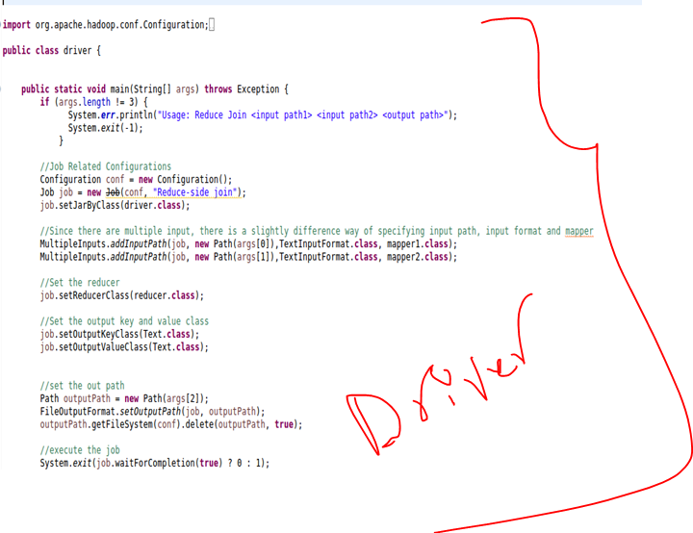

**Mapper class 1:**

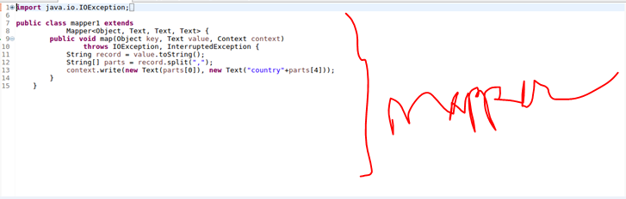

**Mapper class 2:**

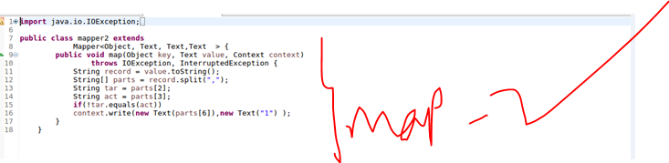

**Reducer class:**

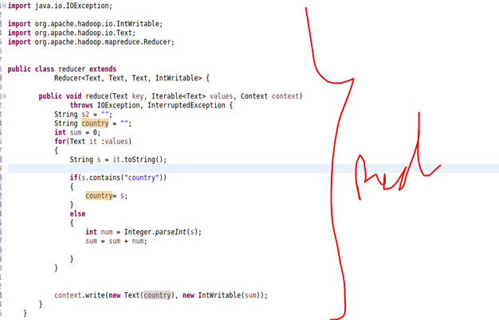

**Output:**

